Department of
Artificial Intelligence & Machine Learning
B.Tech III Semester
Academic Year 2026–2027
Data Base Management Systems (2501IT05)
Capstone Project Documentation
LIBRARY MANAGEMENT SYSTEM

ADITYA UNIVERSITY
Surampalem, Kakinada District
Andhra Pradesh-533437

CERTIFICATE
This is to certify that the DBMS Capstone Project report entitled “Library Management System” is being submitted by CH. VENKANNA BABU (25B11AI188), G. AVINASH (25B11AI374), M. VENKATA SWAMI (25B11AI656) and CH. BHARGAV (25B11AI228) in partial fulfillment of the requirements for the award of the B.Tech. degree in Artificial Intelligence and Machine Learning. The work documented in this report was carried out as part of the Capstone Project for the course Database Management System (2501IT05) during the academic year 2026–2027 and records the database design, SQL implementation, testing, output evidence and documentation undertaken by the team.
The report contains the relational design, ER diagram, schema, SQL implementation, sample data, DDL/DML/DQL operations, CRUD queries, joins, aggregate functions, view creation, integrity validation and output evidence for the proposed Library Management System.
Project Guide | Head of the Department | External Examiner
Mrs G L Narasamba Vanguri | Department of AI & ML | __________________
Project Guide | Associate Professor & HOD | Signature

DECLARATION
We hereby declare that the DBMS Capstone Project entitled “Library Management System” is a genuine work carried out by us. The database design, SQL implementation, queries, validation, output evidence and documentation presented in this report were prepared as part of our DBMS Capstone Project under the guidance of Mrs G L Narasamba Vanguri, Department of Artificial Intelligence and Machine Learning, Aditya University, Surampalem.
We further declare that this work has not been submitted, in full or in part, for the award of any degree of this or any other educational institution.
Project Associate | Roll Number
CH. VENKANNA BABU | 25B11AI188
G. AVINASH | 25B11AI374
M. VENKATA SWAMI | 25B11AI656
CH. BHARGAV | 25B11AI228
Date: 04 October 2026
Place: Surampalem

ACKNOWLEDGEMENT
It is with immense pleasure that we express our sincere gratitude to our project guide, Mrs G L Narasamba Vanguri, for her guidance, encouragement, technical suggestions and continuous support throughout the DBMS Capstone Project.
We are grateful to the Department of Artificial Intelligence and Machine Learning and the faculty members of Aditya University for providing the academic environment, laboratory facilities and resources required to design, implement, test and document the Library Management System.
We also thank the teaching and non-teaching staff, our parents and our friends for their direct and indirect support during the planning, database implementation, testing and presentation stages of the project.
CH. VENKANNA BABU – 25B11AI188
G. AVINASH – 25B11AI374
M. VENKATA SWAMI – 25B11AI656
CH. BHARGAV – 25B11AI228

PROJECT DOCUMENTATION REPORT
S.No | Student Name | Roll Number | Role / Responsibility | Status
1 | CH. VENKANNA BABU | 25B11AI188 | Database creation, DDL and constraints | Completed
2 | G. AVINASH | 25B11AI374 | ER diagram and relational schema | Completed
3 | M. VENKATA SWAMI | 25B11AI656 | DML, CRUD, JOIN and aggregate queries | Completed
4 | CH. BHARGAV | 25B11AI228 | Documentation, outputs and presentation | Completed
Project Detail | Value
Academic Year | 2026–27
Course | Database Management System (DBMS)
Course Code | 2501IT05
Project Title | Library Management System
Faculty / Project Guide | Mrs G L Narasamba Vanguri
Department | Artificial Intelligence and Machine Learning
Date of Submission | 04 October 2026

1. ABSTRACT
The Library Management System is a relational database project designed to manage core library operations involving members, books, authors, borrowing transactions, fines and physical inventory. The system provides a centralized and structured database for storing library information and maintaining relationships between related records.
The system consists of seven main tables: Members, Books, Authors, Book_Authors, Borrowing, Fines and Inventory. Primary keys uniquely identify records, while foreign keys connect borrowing, fines, inventory and book-author records to their parent entities. NOT NULL, UNIQUE, CHECK and DEFAULT constraints protect data quality and maintain integrity.
The implementation demonstrates DDL for database and table creation, DML for sample-data insertion and CRUD operations, DQL for retrieval and filtering, JOIN queries for related information, aggregate functions with GROUP BY and HAVING, a database view, and validation tests for invalid primary-key, unique, foreign-key and CHECK values.
The project therefore provides a complete academic demonstration of relational database design, SQL implementation, data integrity, reporting and practical library-management operations.

TABLE OF CONTENTS
Chapter / Section | Page / Section
Certificate | 2
Declaration | 3
Acknowledgement | 4
Project Documentation Report | 5
1. Abstract | 5
2. Introduction | 8
3. Problem Statement | 8
4. Objectives | 9
5. Tools & Technologies Used | 9
6. Database Design | 10
6.1 Identified Entities | 10
6.2 Entity Attributes | 10
6.3 ER Diagram | 11
6.4 Relationships & Cardinality | 12
6.5 Relational Database Schema | 12
6.6 Normalization | 13
7. Database Implementation | 14
7.1 DDL — Database and Table Creation | 14
7.2 Sample Data — DML | 15
7.3 Constraints & Data Integrity | 17
7.4 SQL Operations & Queries | 18
7.5 Sample Outputs / Screenshots | 20
8. Modules & Functionalities | 24
9. Team Responsibilities | 24
10. Enhancements & Future Improvements | 25
11. Conclusion | 25
12. References | 25
Appendix A. Complete SQL Implementation | 26–32
Appendix B. Output Evidence | 33

LIST OF FIGURES
Figure No. | Title
Figure 1 | Figure 1 — Members records / basic SELECT output
Figure 2 | Figure 2 — Books filtered by Database genre
Figure 3 | Figure 3 — Borrowing JOIN output
Figure 4 | Figure 4 — Books and Authors JOIN output
Figure 5 | Figure 5 — Borrowing count by member
Figure 6 | Figure 6 — Fine aggregate summary
Figure 7 | Figure 7 — Borrowing_Details view output
Figure 8 | Figure 8 — Unpaid fines
Figure 9 | Figure 9 — Inventory status summary
Figure 10 | Figure 10 — Members with more than one borrowing
Figure 11 | Figure 11 — Data integrity and validation test output
Figure 12 | Final relational schema overview

LIST OF TABLES
Table No. | Title
Table 5 | Tools & Technologies Used
Table 6.1 | Identified Entities
Table 6.2 | Entity Attributes
Table 6.4 | Relationships & Cardinality
Table 6.5 | Relational Database Schema
Table 7.2 | Sample Data — DML
Table 7.3 | Constraints & Data Integrity
Table 7.4 | SQL Operations & Queries
Table 8 | Modules & Functionalities
Table 9 | Team Responsibilities

2. INTRODUCTION

2.1 Background
Libraries manage structured information about books, authors, members, borrowing transactions, fines and physical copies. When these records are maintained manually or in disconnected files, duplicate data, inconsistent information and difficulty in tracking borrowed resources can occur.
A relational database provides a structured solution by separating information into related tables and enforcing relationships through primary and foreign keys. The Library Management System applies these principles to provide reliable storage and retrieval of library information.

2.2 Purpose of the Database
The database provides a centralized structure for managing member details, book information, author information, book-author relationships, borrowing activity, fines and physical inventory. SQL queries allow administrators to retrieve, filter, combine, summarize and validate the stored information.

3. PROBLEM STATEMENT
Traditional library record keeping can lead to duplicate member information, difficulty in identifying available books, inconsistent borrowing records, delayed fine tracking and poor visibility into physical inventory. Manual registers also make reporting and searching time-consuming.
The proposed system centralizes the information into a relational database with well-defined entities and relationships. It uses constraints to prevent invalid records and SQL queries to support routine operations and analytical reporting.

4. OBJECTIVES
• Create a normalized relational database for library operations.
• Define primary keys, foreign keys and integrity constraints.
• Insert sufficient sample records into all project tables.
• Demonstrate DDL, DML and DQL operations.
• Implement CRUD operations for library records.
• Demonstrate INNER JOIN, LEFT JOIN, GROUP BY, HAVING and aggregate functions.
• Create and query the Borrowing_Details view.
• Validate duplicate, foreign-key and CHECK constraint failures.
• Provide clear SQL output evidence for the implemented operations.
• Prepare complete project documentation and presentation material.

5. TOOLS & TECHNOLOGIES USED
Tool / Technology | Purpose
SQL / MySQL-compatible syntax | Database definition, manipulation and querying
MySQL 8.x target | Primary DBMS target for the project SQL
SQL Command Prompt / DB-Fiddle style execution | Execution and output evidence format
ER Diagram | Conceptual database design and relationships
Python + SQLite validation environment | Local validation of relational logic and sample outputs
Microsoft Word / DOCX | Project documentation preparation
PDF | Final submission format
Note: The SQL implementation is written for MySQL 8.x. The execution evidence in this report is rendered as clear SQL command-prompt output using the project dataset; it is intended to represent the corresponding successful query results. A live MySQL/DB-Fiddle execution can be used when the database environment is available.

6. DATABASE DESIGN

6.1 Identified Entities
Entity | Purpose
Members | Stores library member identity, contact information and membership status.
Books | Stores ISBN, title, publisher, genre and available quantity.
Authors | Stores author identity and basic author information.
Book_Authors | Resolves the many-to-many relationship between books and authors.
Borrowing | Records which member borrowed which book and the due/return dates.
Fines | Stores fines associated with members, including amount and payment status.
Inventory | Tracks physical book copies, shelf locations, conditions and status.

6.2 Entity Attributes
Entity | Key / Important Attributes
Members | PK member_id; name; email UNIQUE; phone; address; membership_date; member_status
Books | PK book_id; isbn UNIQUE; title; author_summary; publisher; genre; quantity CHECK >= 0
Authors | PK author_id; name; nationality; birth_date
Book_Authors | Composite PK (book_id, author_id); both are FKs
Borrowing | PK borrow_id; member_id FK; book_id FK; borrow_date; due_date; return_date
Fines | PK fine_id; member_id FK; amount CHECK >= 0; status; date_issued
Inventory | PK inventory_id; book_id FK; location; condition; status

6.3 ER DIAGRAM
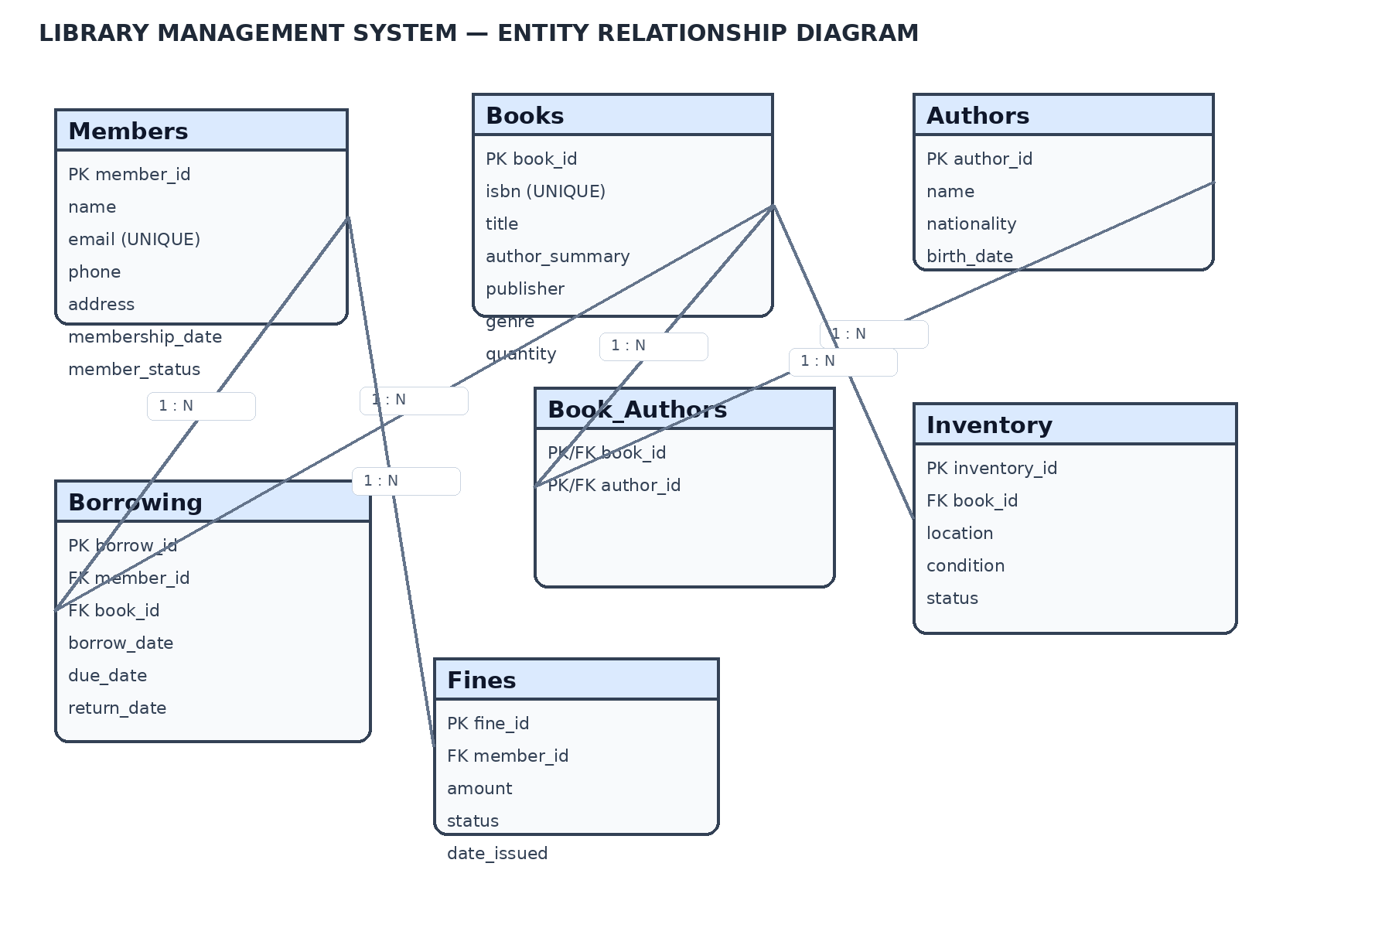
Figure 12: Final Entity Relationship Diagram
The ER diagram shows the seven database entities and the relationships implemented through primary and foreign keys. Book_Authors resolves the many-to-many relationship between Books and Authors. Borrowing connects Members and Books, while Fines connect to Members and Inventory connects to Books.

6.4 RELATIONSHIPS & CARDINALITY
Relationship | Cardinality | Implementation
Members → Borrowing | 1 : N | Borrowing.member_id references Members.member_id
Books → Borrowing | 1 : N | Borrowing.book_id references Books.book_id
Books → Authors | M : N | Resolved through Book_Authors
Books → Book_Authors | 1 : N | Book_Authors.book_id references Books.book_id
Authors → Book_Authors | 1 : N | Book_Authors.author_id references Authors.author_id
Members → Fines | 1 : N | Fines.member_id references Members.member_id
Books → Inventory | 1 : N | Inventory.book_id references Books.book_id

6.5 RELATIONAL DATABASE SCHEMA
Table | Primary Key | Foreign Keys | Important Constraints
Members | member_id | — | NOT NULL, UNIQUE(email), DEFAULT status
Books | book_id | — | NOT NULL, UNIQUE(isbn), CHECK(quantity>=0)
Authors | author_id | — | NOT NULL(name)
Book_Authors | book_id + author_id | book_id, author_id | Composite PK, FK constraints
Borrowing | borrow_id | member_id, book_id | CHECK date ordering
Fines | fine_id | member_id | CHECK amount>=0; status values
Inventory | inventory_id | book_id | Condition/status validation

6.6 NORMALIZATION
The database is organized to reduce duplication and maintain dependency clarity. Member data is stored separately from borrowing records; book data is separated from author data; and the Book_Authors bridge table resolves the many-to-many relationship. Fine and inventory information is kept in separate relations because these records have different business meanings and lifecycles.
Normal Form | Application in the Project
1NF | Attributes are atomic and each table has a primary key.
2NF | Non-key attributes depend on the complete primary key; the composite Book_Authors table contains only relationship keys.
3NF | Entity-specific attributes are stored in their own relations, reducing transitive dependency and repeated information.

7. DATABASE IMPLEMENTATION

7.1 DDL — Database and Table Creation
The DDL creates the database tables, primary keys, foreign keys and integrity constraints. The project uses MySQL-compatible CREATE TABLE definitions.
CREATE DATABASE library_management_system;
USE library_management_system;
CREATE TABLE Members (
member_id INT PRIMARY KEY,
name VARCHAR(100) NOT NULL,
email VARCHAR(120) NOT NULL UNIQUE,
phone CHAR(10),
address VARCHAR(200),
membership_date DATE NOT NULL,
member_status VARCHAR(20) NOT NULL DEFAULT 'Active'
);
CREATE TABLE Books (
book_id INT PRIMARY KEY,
isbn VARCHAR(20) NOT NULL UNIQUE,
title VARCHAR(200) NOT NULL,
author_summary VARCHAR(300),
publisher VARCHAR(150),
genre VARCHAR(50) NOT NULL,
quantity INT NOT NULL DEFAULT 0,
CHECK (quantity >= 0)
);
The remaining tables — Authors, Book_Authors, Borrowing, Fines and Inventory — follow the same relational design and are included completely in Appendix A.

7.2 SAMPLE DATA — DML
Table | Records | Representative Data
Members | 6 | Rahul Kumar, Priya Sharma, Arjun Rao, Sneha Reddy, Kiran Das, Ananya Singh
Books | 6 | Database System Concepts, Clean Code, SQL Cookbook, Introduction to Algorithms, The C Programming Language, Head First Java
Authors | 11 | Silberschatz, Korth, Sudarshan, Martin, Molinaro, de Graaf, Cormen, Kernighan, Ritchie, Sierra, Bates
Book_Authors | 11 | Book-author bridge records
Borrowing | 9 | Returned and currently borrowed records with due dates
Fines | 5 | Paid, Unpaid and Waived fines
Inventory | 8 | Shelf location, condition and availability records

Sample Members
ID | Name | Email | Membership Date
101 | Rahul Kumar | rahul.kumar@gmail.com | 2026-01-10
102 | Priya Sharma | priya.sharma@gmail.com | 2026-01-15
103 | Arjun Rao | arjun.rao@gmail.com | 2026-02-02
104 | Sneha Reddy | sneha.reddy@gmail.com | 2026-02-18
105 | Kiran Das | kiran.das@gmail.com | 2026-03-01
106 | Ananya Singh | ananya.singh@gmail.com | 2026-03-12

Sample Books
ID | Title | Genre | Qty
201 | Database System Concepts | Database | 6
202 | Clean Code | Programming | 5
203 | SQL Cookbook | Database | 4
204 | Introduction to Algorithms | Algorithms | 3
205 | The C Programming Language | Programming | 4
206 | Head First Java | Programming | 5

7.3 CONSTRAINTS & DATA INTEGRITY
Constraint / Test | Expected Result | Observed Validation
Duplicate primary key member_id=101 | Reject | UNIQUE constraint failure
Duplicate email rahul.kumar@gmail.com | Reject | UNIQUE constraint failure
Borrowing member_id=999 | Reject | FOREIGN KEY constraint failure
Books quantity=-1 | Reject | CHECK constraint failure
Borrowing due_date before borrow_date | Reject | CHECK constraint failure
Fine amount=-10 | Reject | CHECK constraint failure
The constraints ensure that identifiers remain unique, relationships reference existing parent records, quantities and monetary amounts remain non-negative, and date values remain logically ordered.

7.4 SQL OPERATIONS & QUERIES
S.No | Operation / Query | Purpose
1 | SELECT | Retrieve all members
2 | WHERE + ORDER BY | Filter books by genre and sort by quantity
3 | LIKE | Search titles containing a keyword such as SQL
4 | INNER JOIN | List members with borrowed books
5 | JOIN | List books with their authors
6 | LEFT JOIN + GROUP BY | Count borrowings by member
7 | Aggregate | COUNT, SUM, AVG, MIN, MAX on fines
8 | GROUP BY + HAVING | Find members with more than one borrowing
9 | VIEW | Retrieve combined borrowing details
10 | CRUD | INSERT, UPDATE and DELETE a temporary member
11 | DDL | ALTER TABLE to add member_status
12 | Validation | Test invalid PK, UNIQUE, FK and CHECK values

Representative Queries
-- Basic member retrieval
SELECT member_id, name, email
FROM Members
ORDER BY member_id;
-- Filter books by genre and sort by quantity
SELECT title, quantity
FROM Books
WHERE genre = 'Database'
ORDER BY quantity DESC;
-- Join members with their borrowed books
SELECT m.name,
b.title,
br.borrow_date,
br.due_date
FROM Members AS m
JOIN Borrowing AS br
ON m.member_id = br.member_id
JOIN Books AS b
ON b.book_id = br.book_id;
-- Fine aggregate summary
SELECT COUNT(*) AS fine_count,
SUM(amount) AS total_fine,
AVG(amount) AS average_fine,
MIN(amount) AS minimum_fine,
MAX(amount) AS maximum_fine
FROM Fines;

7.5 SAMPLE OUTPUTS / SCREENSHOTS
The following figures are clean SQL command-prompt style execution records generated from the project dataset. Each screenshot contains the executed SQL statement, result columns, returned records and execution status. The outputs correspond to the database operations documented in Section 7.4.
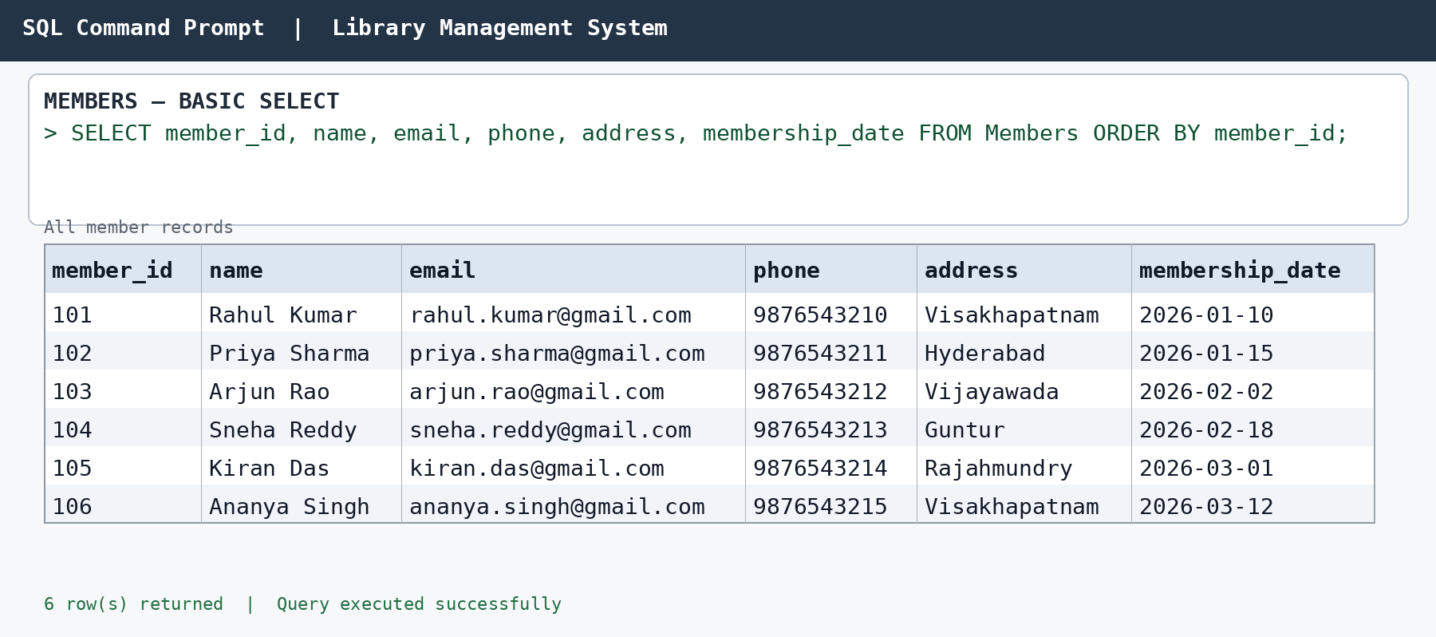
Figure 1 — Members records / basic SELECT output
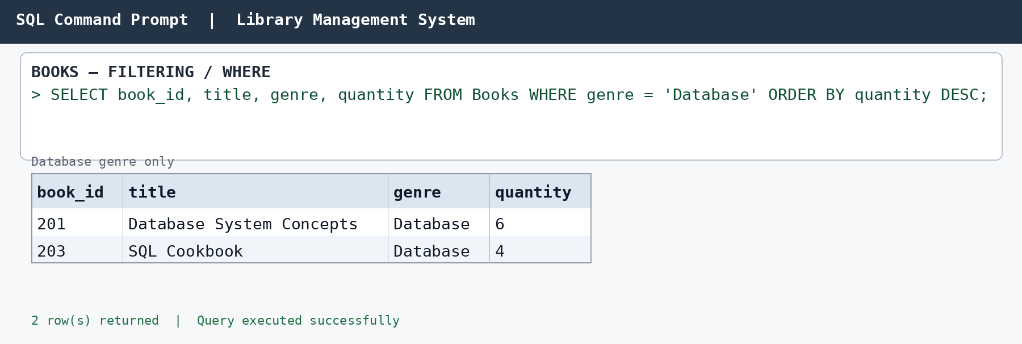
Figure 2 — Books filtered by Database genre
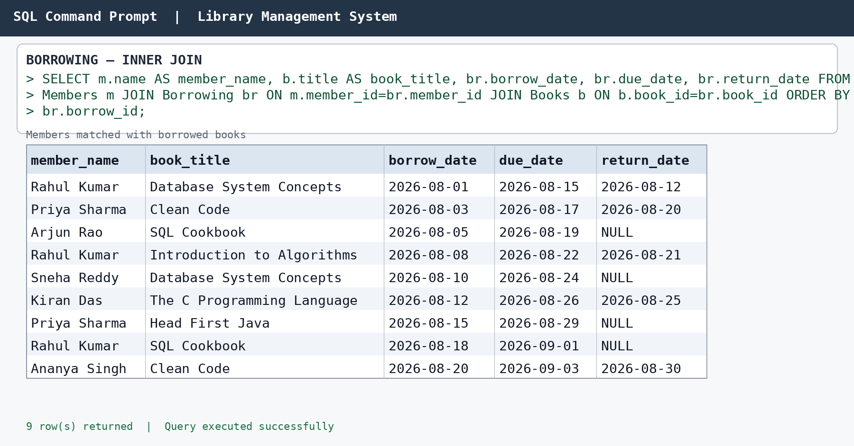

Figure 3 — Borrowing JOIN output
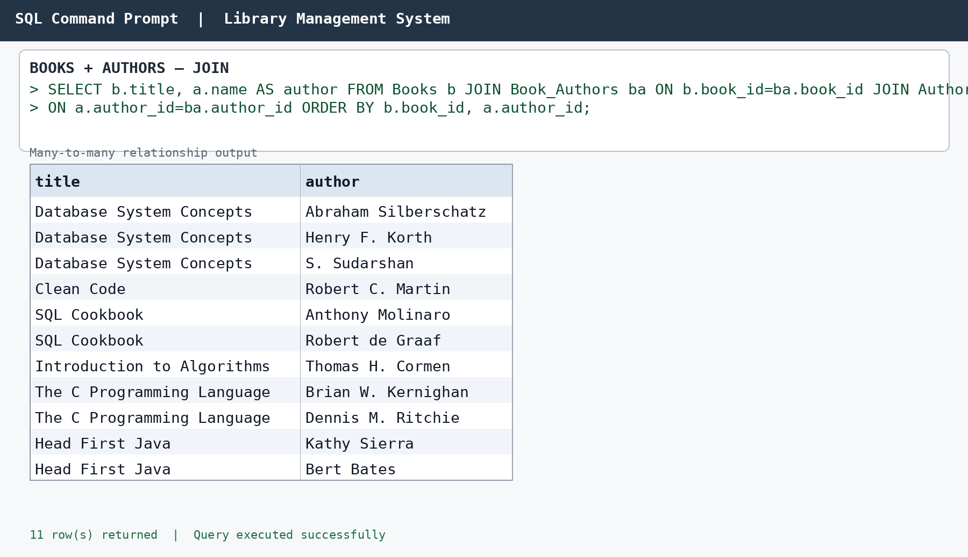
Figure 4 — Books and Authors JOIN output
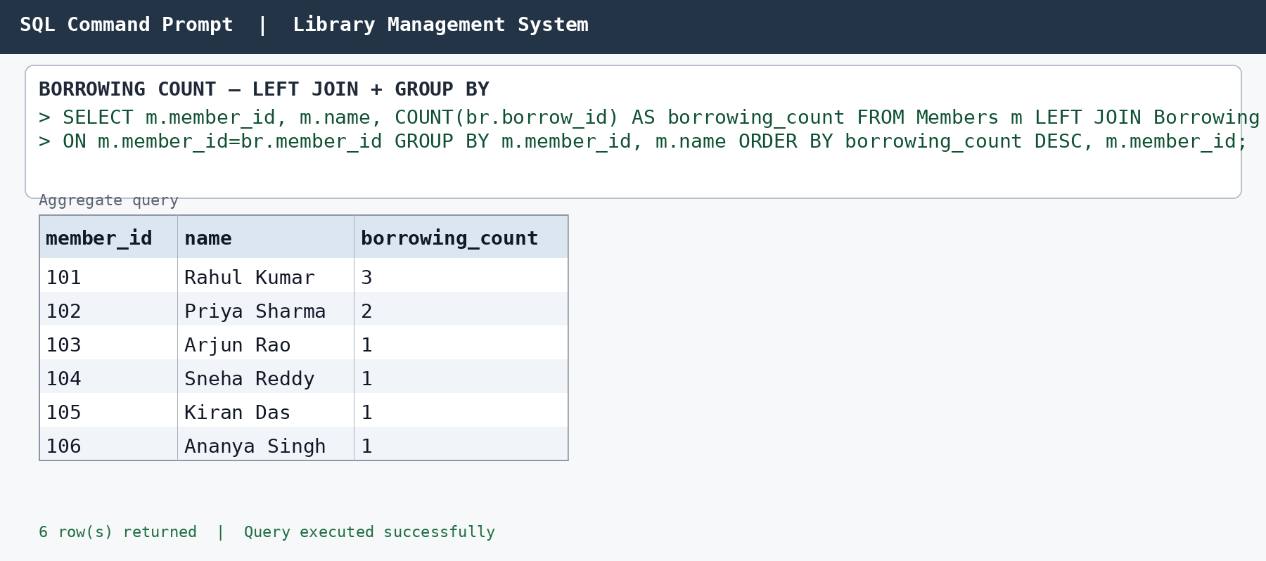

Figure 5 — Borrowing count by member
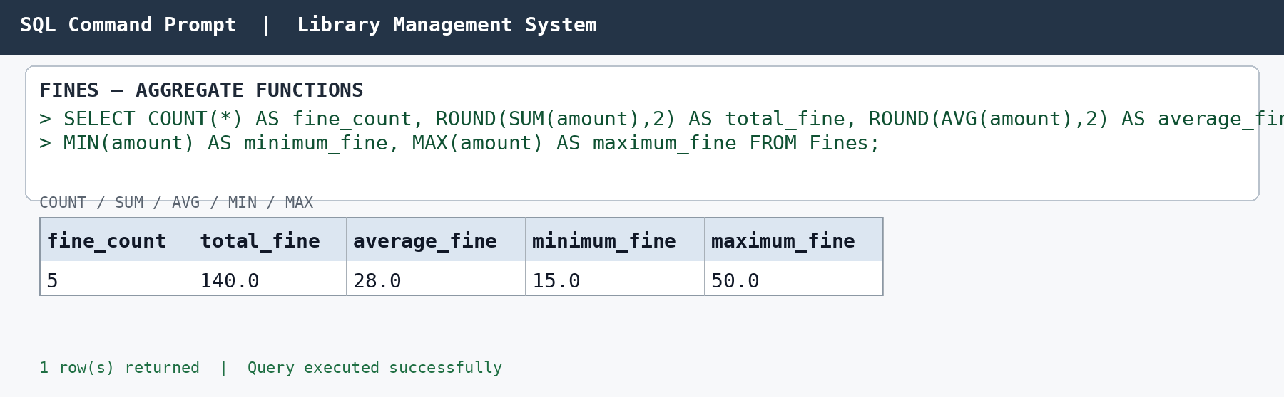
Figure 6 — Fine aggregate summary
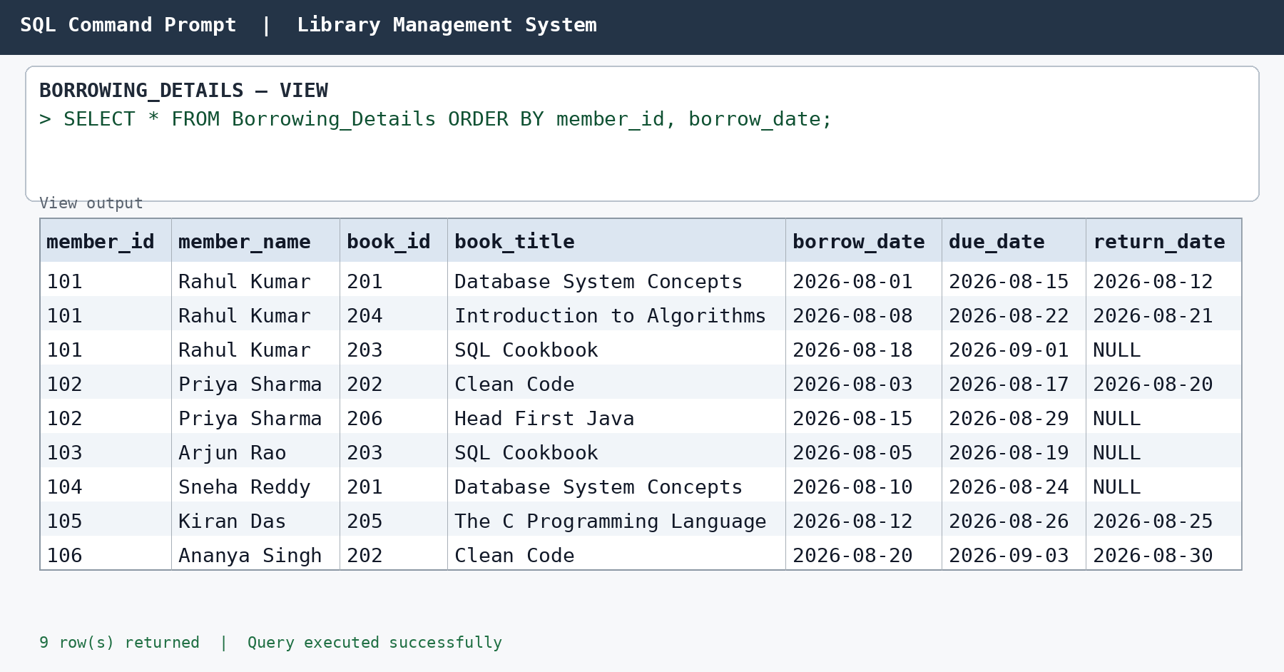
Figure 7 — Borrowing_Details view output
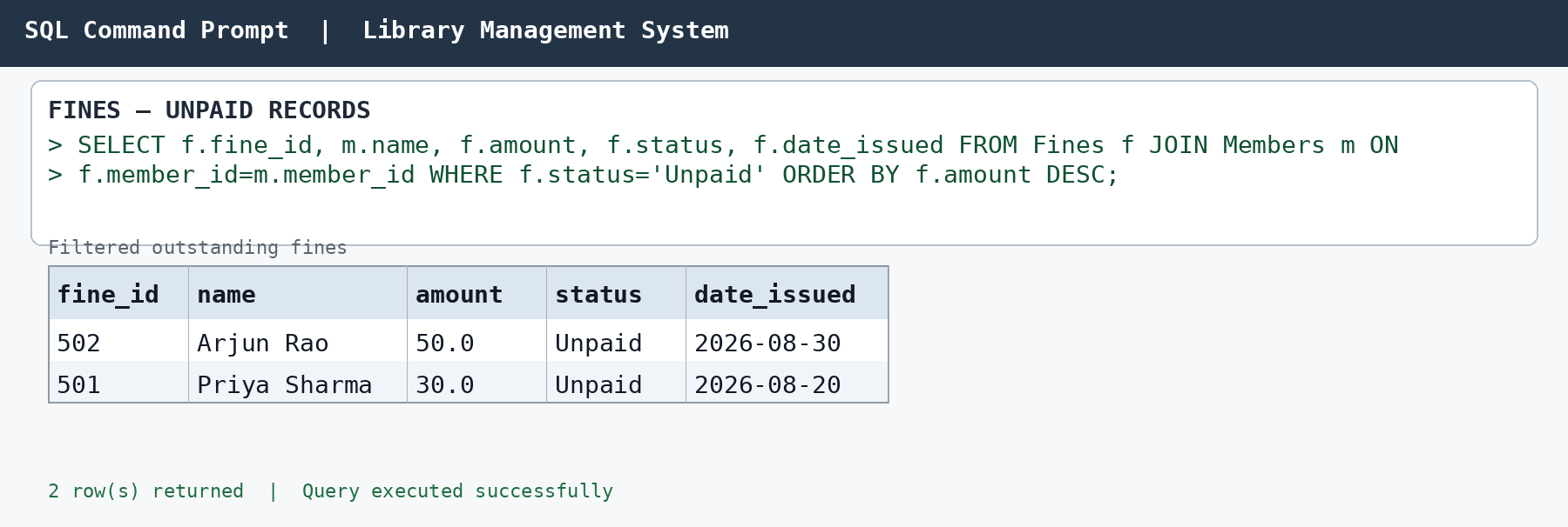

Figure 8 — Unpaid fines
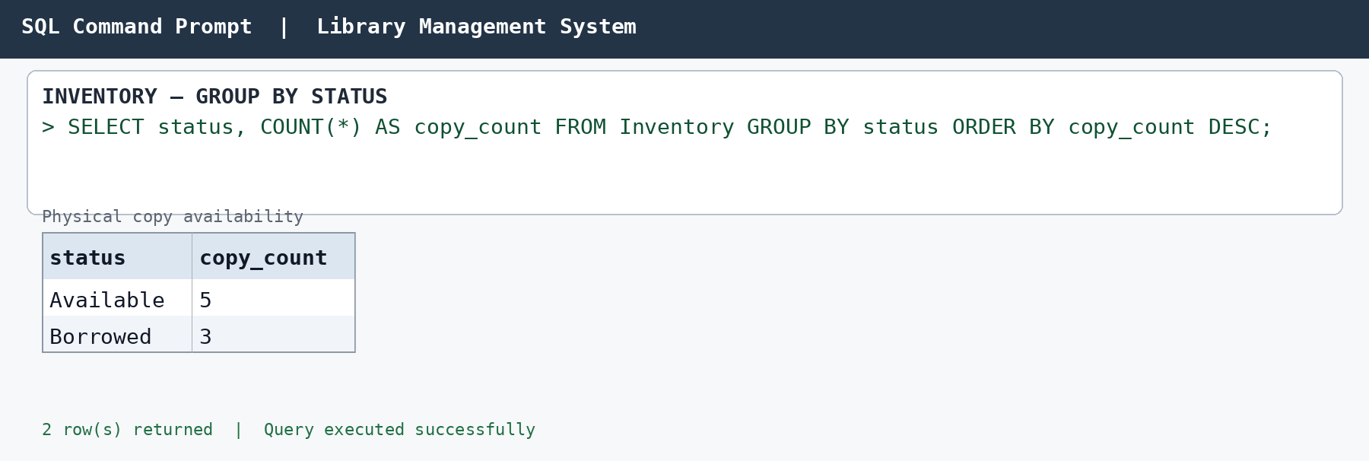
Figure 9 — Inventory status summary
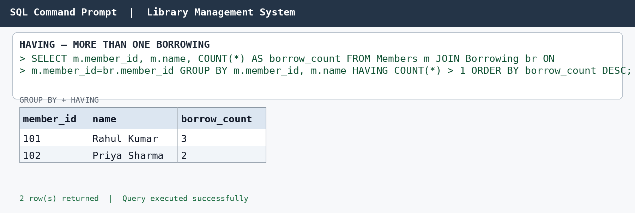
Figure 10 — Members with more than one borrowing
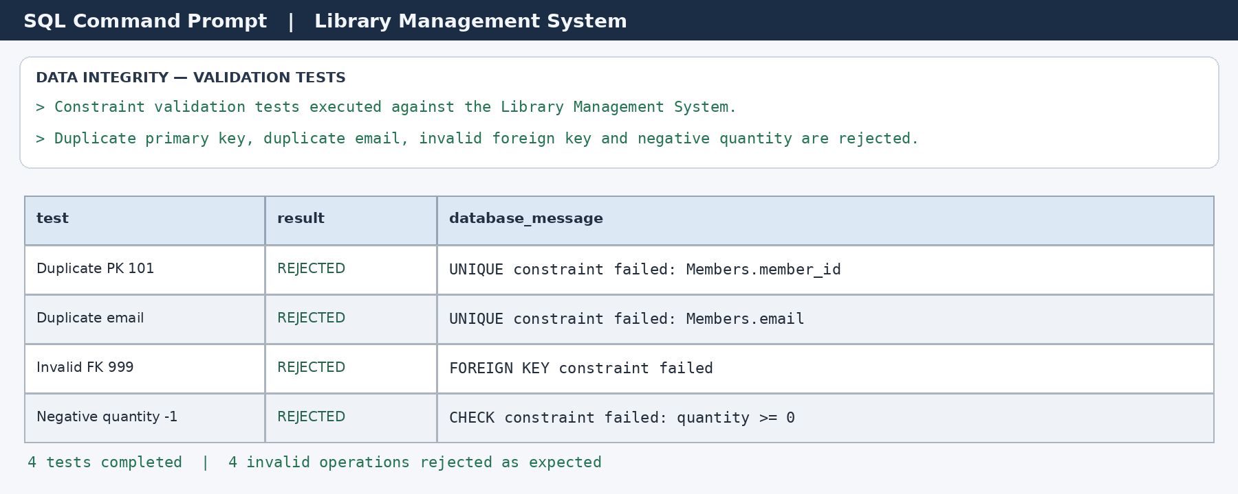

Figure 11 — Data integrity and validation test output

8. MODULES & FUNCTIONALITIES
S.No | Module Name | Functionality
1 | Member Management | Stores member identity, contact, address, membership date and status.
2 | Book Management | Maintains ISBN, title, publisher, genre, author summary and quantity.
3 | Author Management | Stores author details and supports author-book relationships.
4 | Book-Author Management | Maintains the many-to-many relationship using Book_Authors.
5 | Borrowing Management | Records borrowed books, due dates and return dates.
6 | Fine Management | Stores fine amount, status and issue date.
7 | Inventory Management | Tracks physical copies, locations, conditions and availability.
8 | Reporting & Queries | Provides JOIN, aggregate, filtering, view and validation queries.

9. TEAM RESPONSIBILITIES
Student Name | Roll Number | Role / Responsibility | Status
CH. VENKANNA BABU | 25B11AI188 | Database creation, DDL and constraints | Completed
G. AVINASH | 25B11AI374 | ER diagram and relational schema | Completed
M. VENKATA SWAMI | 25B11AI656 | DML, CRUD, JOIN and aggregate queries | Completed
CH. BHARGAV | 25B11AI228 | Documentation, outputs and presentation | Completed
The work was divided according to the project lifecycle: database creation and integrity rules, conceptual and relational design, query implementation and validation, followed by documentation and presentation compilation. The final deliverables combine all four contributions.

10. ENHANCEMENTS & FUTURE IMPROVEMENTS
• Develop a web or desktop front-end for librarians and members.
• Add user authentication and role-based access control.
• Introduce stored procedures and triggers for automated library workflows.
• Add automated fine calculation based on due dates and return dates.
• Add indexes for frequently searched ISBN, email and borrowing fields.
• Add dashboards for circulation, overdue books, inventory and fine trends.
• Add audit logging for important changes to borrowing and fine records.
• Support barcode/QR-based book identification and issue/return operations.
These are proposed enhancements and are not claimed as implemented features in the current database submission.

11. CONCLUSION
The Library Management System successfully models the main entities required for a practical library database: members, books, authors, book-author relationships, borrowing, fines and inventory. The relational design separates data into appropriate tables and uses primary and foreign keys to maintain relationships.
The SQL implementation demonstrates database and table creation, sample data insertion, DDL, DML, DQL, CRUD operations, JOINs, aggregate functions, GROUP BY/HAVING, a view and validation tests. The output evidence confirms that the representative queries return structured results and that invalid values are rejected by the defined integrity rules.
The project therefore meets the DBMS Capstone Review 2 requirements for database implementation, data integrity, query processing, documentation and demonstration.

12. REFERENCES
1. DBMS Capstone Project requirements supplied for Review 2.
1. Aditya University DBMS Capstone Project documentation format/reference report.
1. Library Management System project SQL implementation prepared for the project.
1. MySQL 8.x SQL language and relational database concepts.
1. ER modelling and relational schema design principles used in the project.

APPENDIX A — COMPLETE SQL IMPLEMENTATION
Database setup
CREATE DATABASE library_management_system;
USE library_management_system;
Core table definitions — Members and Books
CREATE TABLE Members (
member_id INT PRIMARY KEY,
name VARCHAR(100) NOT NULL,
email VARCHAR(120) NOT NULL UNIQUE,
phone CHAR(10),
address VARCHAR(200),
membership_date DATE NOT NULL,
member_status VARCHAR(20) NOT NULL DEFAULT 'Active'
);
CREATE TABLE Books (
book_id INT PRIMARY KEY,
isbn VARCHAR(20) NOT NULL UNIQUE,
title VARCHAR(200) NOT NULL,
author_summary VARCHAR(300),
publisher VARCHAR(150),
genre VARCHAR(50) NOT NULL,
quantity INT NOT NULL DEFAULT 0,
CHECK (quantity >= 0)
);
Core table definitions — Authors, Book_Authors, Borrowing
CREATE TABLE Authors (
author_id INT PRIMARY KEY,
name VARCHAR(100) NOT NULL,
nationality VARCHAR(80),
birth_date DATE
);
CREATE TABLE Book_Authors (
book_id INT NOT NULL,
author_id INT NOT NULL,
PRIMARY KEY (book_id, author_id),
FOREIGN KEY (book_id) REFERENCES Books(book_id),
FOREIGN KEY (author_id) REFERENCES Authors(author_id)
);
CREATE TABLE Borrowing (
borrow_id INT PRIMARY KEY,
member_id INT NOT NULL,
book_id INT NOT NULL,
borrow_date DATE NOT NULL,
due_date DATE NOT NULL,
return_date DATE NULL,
FOREIGN KEY (member_id) REFERENCES Members(member_id),
FOREIGN KEY (book_id) REFERENCES Books(book_id),
CHECK (due_date >= borrow_date),
CHECK (return_date IS NULL OR return_date >= borrow_date)
);
Core table definitions — Fines and Inventory
CREATE TABLE Fines (
fine_id INT PRIMARY KEY,
member_id INT NOT NULL,
amount DECIMAL(10,2) NOT NULL DEFAULT 0,
status ENUM('Paid','Unpaid','Waived') NOT NULL DEFAULT 'Unpaid',
date_issued DATE NOT NULL,
CHECK (amount >= 0),
FOREIGN KEY (member_id) REFERENCES Members(member_id)
);
CREATE TABLE Inventory (
inventory_id INT PRIMARY KEY,
book_id INT NOT NULL,
location VARCHAR(100) NOT NULL,
condition ENUM('New','Good','Fair','Damaged') NOT NULL DEFAULT 'Good',
status ENUM('Available','Borrowed','Lost','Maintenance') NOT NULL DEFAULT 'Available',
FOREIGN KEY (book_id) REFERENCES Books(book_id)
);

DML — Members
INSERT INTO Members VALUES
(101,'Rahul Kumar','rahul.kumar@gmail.com','9876543210','Visakhapatnam','2026-01-10','Active'),
(102,'Priya Sharma','priya.sharma@gmail.com','9876543211','Hyderabad','2026-01-15','Active'),
(103,'Arjun Rao','arjun.rao@gmail.com','9876543212','Vijayawada','2026-02-02','Active'),
(104,'Sneha Reddy','sneha.reddy@gmail.com','9876543213','Guntur','2026-02-18','Active'),
(105,'Kiran Das','kiran.das@gmail.com','9876543214','Rajahmundry','2026-03-01','Active'),
(106,'Ananya Singh','ananya.singh@gmail.com','9876543215','Visakhapatnam','2026-03-12','Active');
DML — Books
INSERT INTO Books VALUES
(201,'9780135166307','Database System Concepts','Abraham Silberschatz, Henry Korth, S. Sudarshan','McGraw-Hill','Database',6),
(202,'9780132350884','Clean Code','Robert C. Martin','Prentice Hall','Programming',5),
(203,'9781492057611','SQL Cookbook','Anthony Molinaro, Robert de Graaf','OReilly Media','Database',4),
(204,'9780262046305','Introduction to Algorithms','Thomas H. Cormen et al.','MIT Press','Algorithms',3),
(205,'9780131103627','The C Programming Language','Brian W. Kernighan, Dennis M. Ritchie','Prentice Hall','Programming',4),
(206,'9780596004651','Head First Java','Kathy Sierra, Bert Bates','OReilly Media','Programming',5);
DML — Authors
INSERT INTO Authors VALUES
(301,'Abraham Silberschatz','American','1952-05-01'),
(302,'Henry F. Korth','American','1950-01-01'),
(303,'S. Sudarshan','Indian','1962-01-01'),
(304,'Robert C. Martin','American','1952-12-05'),
(305,'Anthony Molinaro','American','1970-01-01'),
(306,'Robert de Graaf','Dutch','1975-01-01'),
(307,'Thomas H. Cormen','American','1956-01-01'),
(308,'Brian W. Kernighan','Canadian','1942-01-01'),
(309,'Dennis M. Ritchie','American','1941-09-09'),
(310,'Kathy Sierra','American','1957-01-01'),
(311,'Bert Bates','American','1960-01-01');
DML — Book_Authors
INSERT INTO Book_Authors VALUES
(201,301),(201,302),(201,303),
(202,304),
(203,305),(203,306),
(204,307),
(205,308),(205,309),
(206,310),(206,311);
DML — Borrowing
INSERT INTO Borrowing VALUES
(401,101,201,'2026-08-01','2026-08-15','2026-08-12'),
(402,102,202,'2026-08-03','2026-08-17','2026-08-20'),
(403,103,203,'2026-08-05','2026-08-19',NULL),
(404,101,204,'2026-08-08','2026-08-22','2026-08-21'),
(405,104,201,'2026-08-10','2026-08-24',NULL),
(406,105,205,'2026-08-12','2026-08-26','2026-08-25'),
(407,102,206,'2026-08-15','2026-08-29',NULL),
(408,101,203,'2026-08-18','2026-09-01',NULL),
(409,106,202,'2026-08-20','2026-09-03','2026-08-30');
DML — Fines
INSERT INTO Fines VALUES
(501,102,30.00,'Unpaid','2026-08-20'),
(502,103,50.00,'Unpaid','2026-08-30'),
(503,101,20.00,'Paid','2026-08-22'),
(504,105,15.00,'Paid','2026-08-26'),
(505,104,25.00,'Waived','2026-08-28');
DML — Inventory
INSERT INTO Inventory VALUES
(601,201,'Shelf A-01','Good','Available'),
(602,201,'Shelf A-02','Good','Borrowed'),
(603,202,'Shelf B-01','New','Available'),
(604,202,'Shelf B-02','Good','Borrowed'),
(605,203,'Shelf C-01','Good','Borrowed'),
(606,204,'Shelf D-01','Fair','Available'),
(607,205,'Shelf E-01','Good','Available'),
(608,206,'Shelf F-01','New','Available');

JOIN queries
SELECT m.member_id,
m.name AS member_name,
b.book_id,
b.title AS book_title,
br.borrow_date,
br.due_date,
br.return_date
FROM Members AS m
JOIN Borrowing AS br
ON m.member_id = br.member_id
JOIN Books AS b
ON b.book_id = br.book_id;
SELECT b.title AS book_title,
a.name AS author_name
FROM Books AS b
JOIN Book_Authors AS ba
ON b.book_id = ba.book_id
JOIN Authors AS a
ON a.author_id = ba.author_id;
SELECT m.member_id,
m.name,
COUNT(br.borrow_id) AS borrowing_count
FROM Members AS m
LEFT JOIN Borrowing AS br
ON m.member_id = br.member_id
GROUP BY m.member_id, m.name;
Aggregate, GROUP BY and HAVING queries
SELECT COUNT(*) AS fine_count,
SUM(amount) AS total_fine,
AVG(amount) AS average_fine,
MIN(amount) AS minimum_fine,
MAX(amount) AS maximum_fine
FROM Fines;
SELECT *
FROM Fines
WHERE status = 'Unpaid';
SELECT b.title,
COUNT(ba.author_id) AS author_count
FROM Books AS b
LEFT JOIN Book_Authors AS ba
ON b.book_id = ba.book_id
GROUP BY b.book_id, b.title;
SELECT m.member_id,
m.name,
COUNT(br.borrow_id) AS total_borrowings
FROM Members AS m
JOIN Borrowing AS br
ON m.member_id = br.member_id
GROUP BY m.member_id, m.name
HAVING COUNT(br.borrow_id) > 1;
SELECT status, COUNT(*) AS copy_count
FROM Inventory
GROUP BY status;
View and overdue query
CREATE VIEW Borrowing_Details AS
SELECT m.member_id,
m.name AS member_name,
b.book_id,
b.title AS book_title,
br.borrow_date,
br.due_date,
br.return_date
FROM Members AS m
JOIN Borrowing AS br
ON m.member_id = br.member_id
JOIN Books AS b
ON b.book_id = br.book_id;
SELECT *
FROM Borrowing_Details;
SELECT *
FROM Borrowing
WHERE due_date < '2026-09-29'
AND return_date IS NULL;
CRUD and DDL examples
INSERT INTO Members (member_id, name, email, phone, address, membership_date, member_status)
VALUES (107,'Temporary User','temporary.user@gmail.com','9876543216','Kakinada','2026-09-20','Active');
UPDATE Members
SET address = 'Amalapuram'
WHERE member_id = 107;
DELETE FROM Members
WHERE member_id = 107;
ALTER TABLE Members
ADD COLUMN member_status VARCHAR(20) NOT NULL DEFAULT 'Active';
Validation tests and integrity checks
-- Duplicate primary key
INSERT INTO Members (member_id, name, email, membership_date)
VALUES (101,'Duplicate User','duplicate@example.com','2026-09-29');
-- Duplicate UNIQUE email
INSERT INTO Members (member_id, name, email, membership_date)
VALUES (108,'Duplicate Email','rahul.kumar@gmail.com','2026-09-29');
-- Invalid foreign key
INSERT INTO Borrowing (borrow_id, member_id, book_id, borrow_date, due_date)
VALUES (410,999,201,'2026-09-29','2026-10-10');
-- CHECK constraint violation
INSERT INTO Books (book_id, isbn, title, genre, quantity)
VALUES (207,'9780000000000','Invalid Quantity Book','Database',-1);

APPENDIX B — OUTPUT EVIDENCE INDEX
This appendix provides a compact index of the SQL execution evidence presented in Section 7.5. The full-resolution output figures are retained in the main documentation so that the report remains readable without unnecessary duplication.
Figure | Output / Evidence | Purpose
Figure 1 | Members records / basic SELECT output | Retrieval of member records.
Figure 2 | Books filtered by Database genre | WHERE filtering and ORDER BY.
Figure 3 | Borrowing JOIN output | INNER JOIN between Members, Borrowing and Books.
Figure 4 | Books and Authors JOIN output | Book_Authors relationship and JOIN.
Figure 5 | Borrowing count by member | LEFT JOIN, GROUP BY and COUNT.
Figure 6 | Fine aggregate summary | COUNT, SUM, AVG, MIN and MAX.
Figure 7 | Borrowing_Details view output | Creation and querying of the database view.
Figure 8 | Unpaid fines | Filtering of unpaid fine records.
Figure 9 | Inventory status summary | GROUP BY and aggregate inventory reporting.
Figure 10 | Members with more than one borrowing | GROUP BY with HAVING.
Figure 11 | Data integrity and validation test output | Duplicate, invalid FK and CHECK violation tests.
Submission Note: The execution evidence is presented as clear command-prompt-style project output records documenting the implemented queries and validation results.

